Data Structures

1. Implement a function to reverse a list without using built-in reverse().

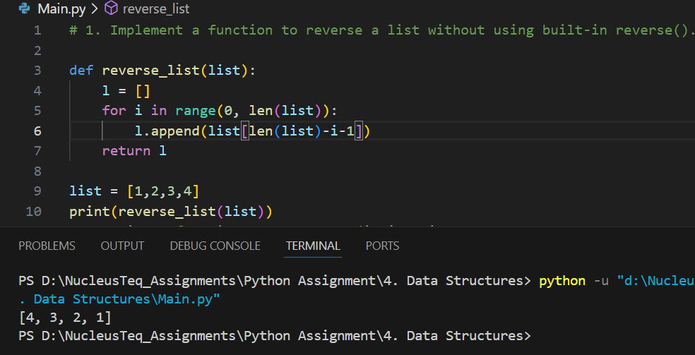

2. Write a function to merge two dictionaries.

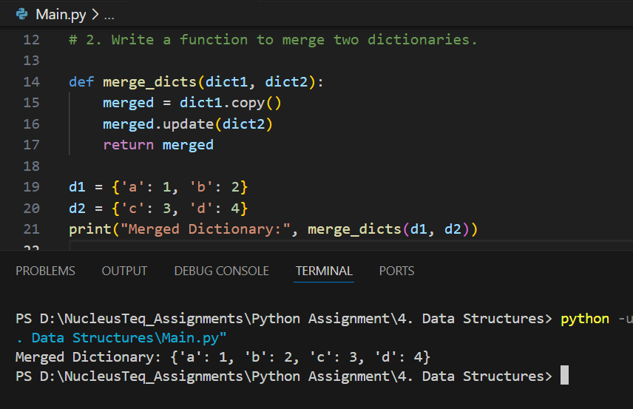

3. Develop a function that removes duplicate elements from a list.

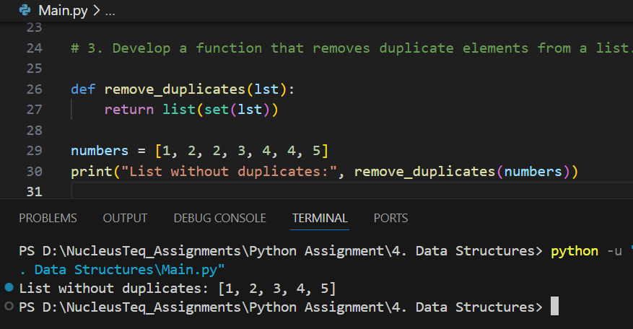

4. Create a function that counts the frequency of each word in a list.

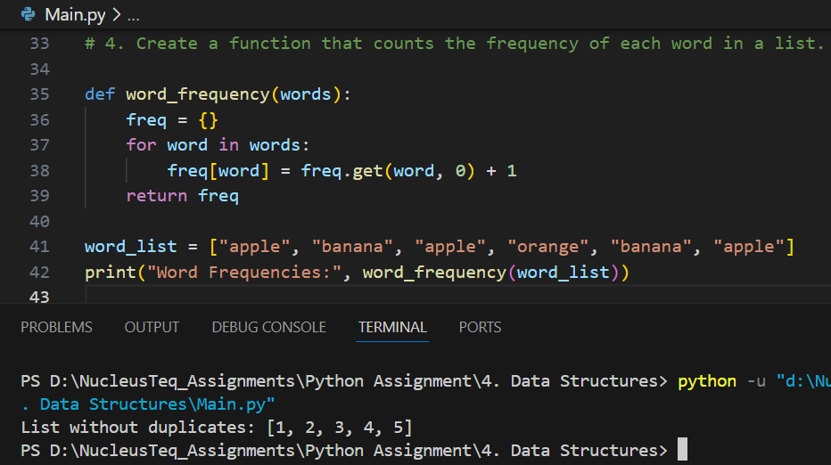

5. Write a program to sort a list of tuples based on the second element.

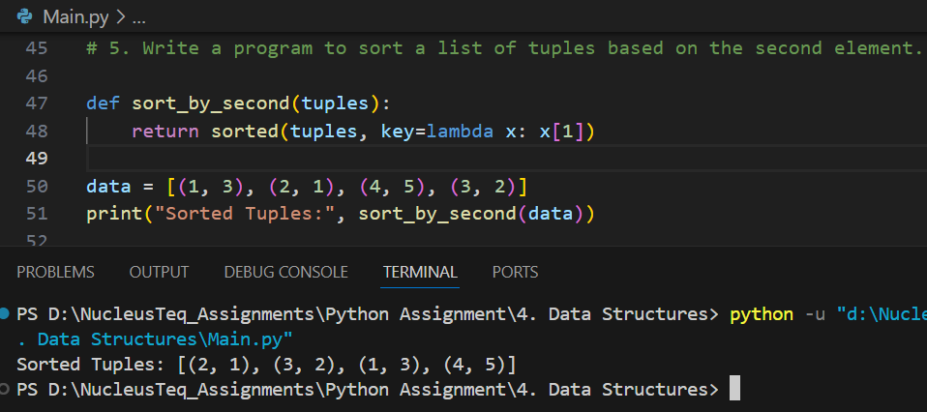

6. Implement a stack using list with push, pop, and peek operations.

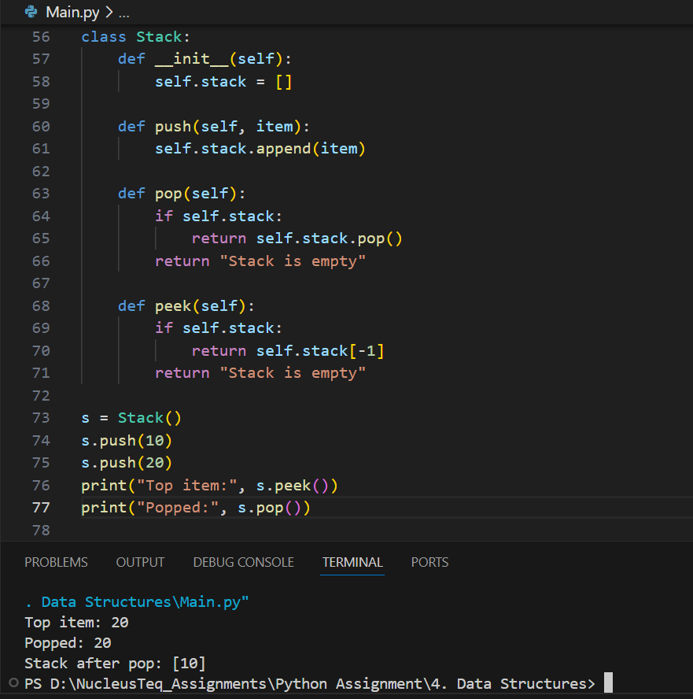

7. Create a queue using collections.deque and implement enqueue and dequeue.

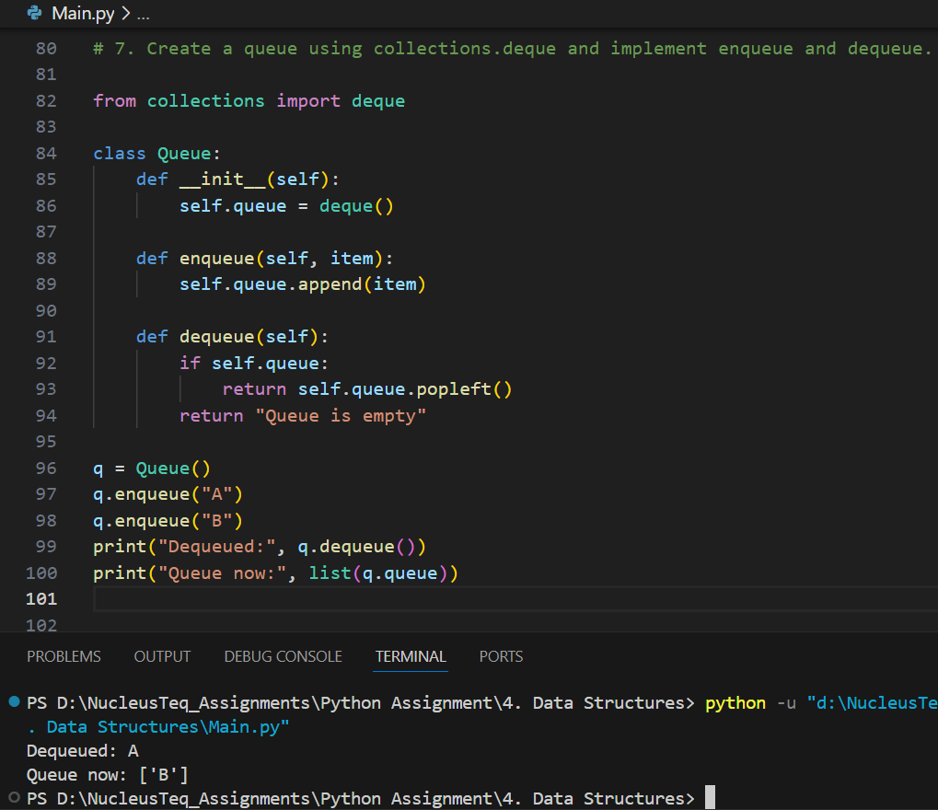

8. Write a function to find the intersection of two lists.

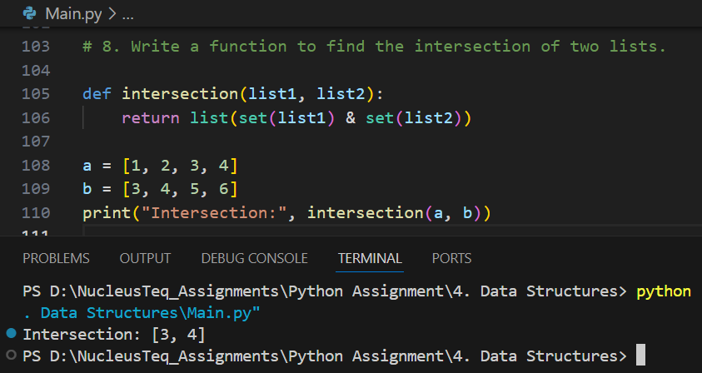

9. Create a program that uses a dictionary to implement a phonebook.

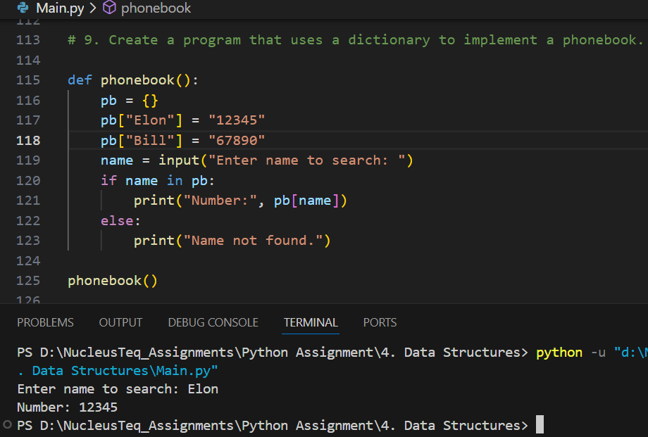

10. Implement a function to check if a list is a palindrome.

